SASD News January 2018

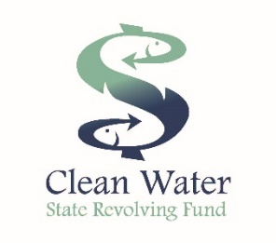
A New Year Begins
2018 is going to be a great year for the Sanitary District! We will complete the engineering phase of the Upgrade Project in June, and select a contractor to begin construction in September. If you recall, we secured a $5.5 Million Dollar grant from the State Revolving Fund to offset the cost of replacing much of our antiquated equipment, some of which dates to the 1950’s. The project will include a new digester, replacement of the old irrigation pump station, and upgrade to the plant’s electrical system.

Elementary School Outreach
Each year, the District partners with the School to educate children in grades 4-6 about the importance of wastewater treatment. The program consists of classroom learning, hands-on learning, and visual learning. This year’s theme was “Give Water a Second Chance: Re-Cycle It!”. During the plant tour in September, students performed hands-on lab testing for pH, dissolved oxygen, and temperature. They also performed microscopic examination of the wastewater samples. Students were also able to see the sewer camera and jetter equipment in service and do some hands-on wrenching. This program is a fantastic long-term investment in the development of our community’s future leaders. And it’s a fun way for kids to experience physical and biological science in the real-world environment.
This outreach program is made possible by generous corporate sponsors and the dedication of District staff. For more information about the Sanitary District and to see fun pictures of this year’s plant tour, go to http://sasanitary.org

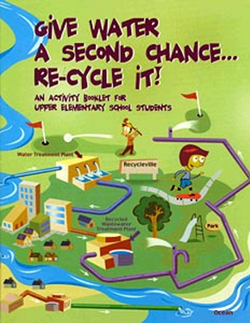

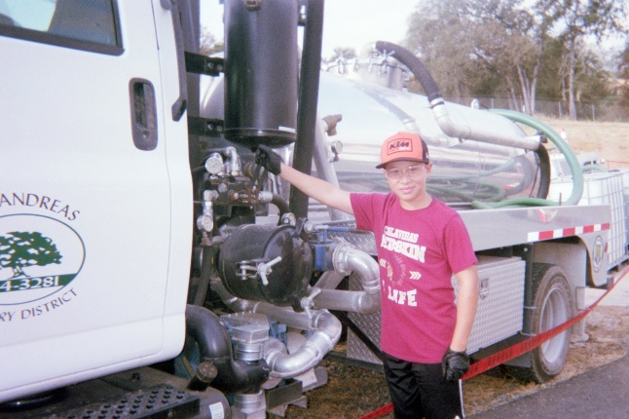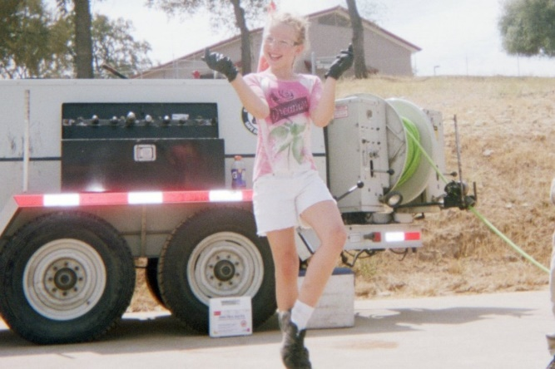

New Flag Monument
In November, the District dedicated a new flag monument in memory of Mr Robert “Bob” Applegate, a longtime member of our Board of Directors. Bob served on the district’s board from 1985 -2017 and passed away last August. The event was open to the public, and we were fortunate to have all of our current and several past board members attend. Bob’s family attended and received a plaque to honor Bob’s service to our District. We will think of Bob each day we see Old Glory flying.
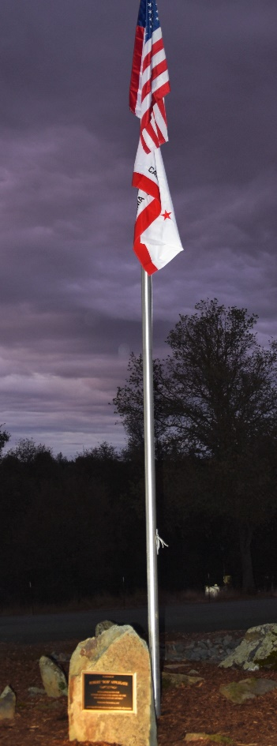

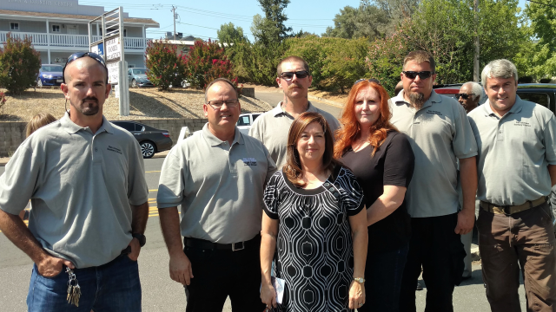
On behalf of all our staff at the Sanitary District, we hope you have a great 2018!

