SASD News September 2017

Mr Robert “Bob” Applegate
All of us at the Sanitary District are saddened about the passing of Mr Robert “Bob” Applegate. He died in August and we extend our deepest condolences to his family and loved ones.
Mr Applegate demonstrated what it means to be a “CITIZEN”. From his years in the military, decades of service as a Peace Officer, and over 30 years of service to our Sanitary District, Bob showed his love and commitment to the greater community.
Mr Applegate served on the District’s Board of Directors since 1985. He provided a high level of professionalism and practical knowledge when making difficult decisions; and he kept a good wit about him to keep things lively.
Bob served as President of our Board as recently as 2015, leading all the regular business discussions that were needed. During his 30 year tenure, several major infrastructure projects were initiated, and his hand was on the shovel of the big groundbreaking ceremonies. Bob was a good Public Steward for our District.
Probably most important to Bob was the relationship with our staff at the district. He kept an attentive ear to the needs of the employees. Bob showed kindness to us and we are grateful to have been connected with him in San Andreas.
Through his life, Bob gave consistent leadership to our entire community, and the void he leaves is significant. We will miss him.

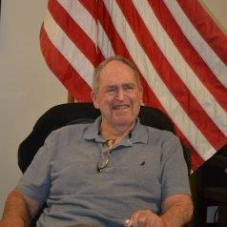
Mr Robert “Bob” Applegate
Served the Board of Directors from 1985 – 2017
Citizen: Family Man, Military Career, Peace Officer, Public Servant

