SASD News March 2017

Rain, Rain, Rain = Inflow and Infiltration

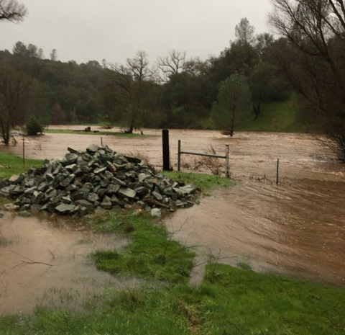
This wet weather season has really kept us moving! While we’re grateful for the precipitation, the heavy rains can create a lot of stress here at the plant to keep the water flowing to the right places. Our plant experienced some record flow totals this Winter, and the river monitoring station was often flooded. Our Operators were able to maintain permit compliance through it all.
As we talked in last Fall’s newsletter, most wastewater plants are susceptible for “I and I”, or inflow and infiltration. Our plant is no exception. I/I occurs when rain water is directed from surface streets or properties directly into our sanitary sewer. It can also occur when groundwater finds its way into cracks or offsets in the sewer pipes. See diagram, below.

Calaveras River Monitoring Station

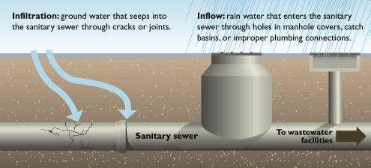
Infiltration and Inflow

Sometimes, our typical daily plant flow of 250,000 gallons will turn into more than 1 million gallons in a day. We recently experienced inflow of 2 Million gallons in one day! When the plant receives this much I/I, it is quite a challenge to keep the plant up and functioning well. The community can help us by making sure there are no illicit connections to our sewer pipes from downspouts or basement sump pumps; also by letting us know if there are manhole covers that are out of place.
Needless to say, a little dry spring weather soon will be more than welcomed!

New Ordinance
The Board of Directors approved a new Ordinance that goes into effect July 1st. This ordinance also reflects the new rate structure that was passed last Fall. You can view the new Ordinance at sasanitary.org
Thank you to our Directors for keeping the District on sound financial footing so we can stay in compliance with all environmental regulations and be prepared for the unexpected.

Upgrade Project and Grant Funding
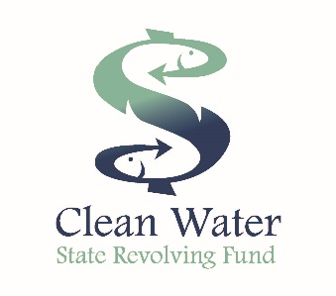
We received good news about the wastewater treatment plant upgrade project. Our efforts to obtain grant funds have been successful and we secured commitment for $5.5 Million in design and construction grants. This is a big deal for our community as we will be able to replace aging infrastructure, improve plant reliability, and increase energy efficiency with little upfront costs to our community. We are hopeful to complete the project design in 2017 and begin construction in the summer of 2018.

On behalf of all our staff at the Sanitary District, we hope you have a great start to Spring!

