San Andreas Sanitary District

YOU’RE INVITED TO TOUR THE WASTEWATER PLANT

Saturday April 30TH

675 Gold Oak Road
Time: 8:00 – 1:00
Tours last about 30 mins and depart at the top and bottom of each hour.
Touring a functioning wastewater treatment plant is an eye-opening experience. Come visit with our Plant Operators and take a walk around the facility and learn how the dirty water is cleaned and where it goes after we’re done with it.

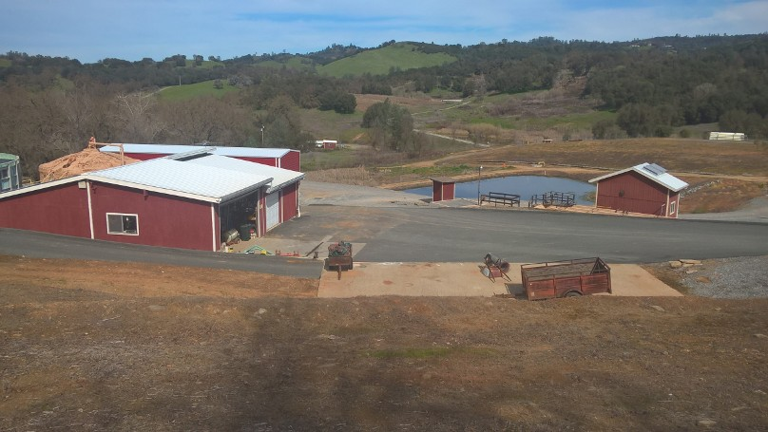
Kids are welcomed as long as they are supervised by an Adult. Comfortable shoes (not flip flops) will help make the tour more enjoyable. We’ll provide some refreshments.
We’ll also have a Yard Sale going on. The items are sold “as-is” and most items will be under $20. Come see what you can find.

